**Title**

NetCanvas – A shared drawing board

**Abstract**

Visual communication has played a major role in the evolution of mankind and even today is the most powerful form of expression of human emotions. This app exploits this fact and targets a particular use case where people can communicate visually with each other instantly via doodling or drawing with the help of the cloud.

**Introduction**

The app allows the involved users to create a shared space on the cloud platform to communicate with each other. This shared space is termed as a canvas. This canvas can receive inputs in the form of swipes and touch inputs that are recorded by the input device which is a mobile phone in most of the cases. The mobile phone records the inputs given to it by the user and uploads it on the cloud. The receiving mobile phone on the other end downloads these recorded inputs and updates its canvas. This way, via internet and cloud space, visual communication with the help of hand gestures is made possible.

**Implementation details**

Cloud Service: The cloud service used in making this application is Google’s Firebase service. Firebase is a technology that permits you to make web applications with no server-side programming so that development turns out to be quicker and easier. With Firebase, we don't have to stress over-provisioning servers or building REST APIs with just a little bit of configuration; we can give Firebase a chance to take every necessary step: storing data, verifying users, and implementing access rules. It supports the web, iOS, OS X, and Android clients. Applications using Firebase can just use and control data, without having to think about how data would be stored, and synchronized across various examples of the application in real time. There is no need to write server side code, or to deploy a complex server framework to get an app started with Firebase.

Input method: There are a number of touch inputs possible on Android devices such as:

1) Two-finger swipe down.

2) Press and hold.

3) Press and hold to select.

4) Swipe down.

5) Triple-tap to zoom in.

6) Tap and hold on menus.

7) Double-tap and hold to zoom

8) Configure your own gestures

The app can use single-touch inputs from the above list viz. 2, 3, 4, 6, 7 and 8 to record inputs of the user. The app converts these gestures into lines by breaking their continuity in lines.

Recording the input: The inputs given by the user are gestures which are irregular shaped contours due to the limitation of human hand movement. The app records these gestures as they are; but for storage, it breaks these gesture inputs and converts them into lines. Further these lines are also broken down into points. These points are then uploaded on Firebase. Firebase has a JSON database and there these inputs are recorded in a hierarchical form.

**Result**

The result is an Android app that can be used in situations where you need to explain something to a person but in visual form. The app is in development stages now, but in future it can have complex functions to record inputs such as auto straightening of lines and curves input by the user.

**Snapshot**

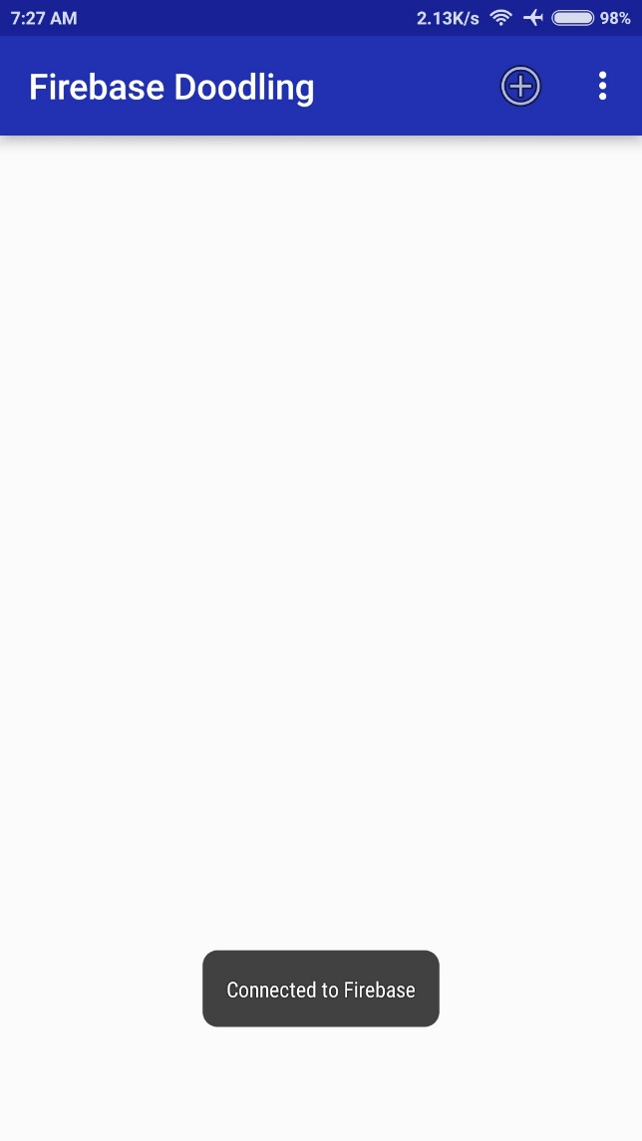Fig 1. Home Screen

Fig 1. Shows the home screen of the app. Here, the app tries to establish connection with Firebase using its unique serial key. Every Firebase based app has its own unique project id. Once the app establishes the connection, it can download the required data by a pull request from Firebase servers.

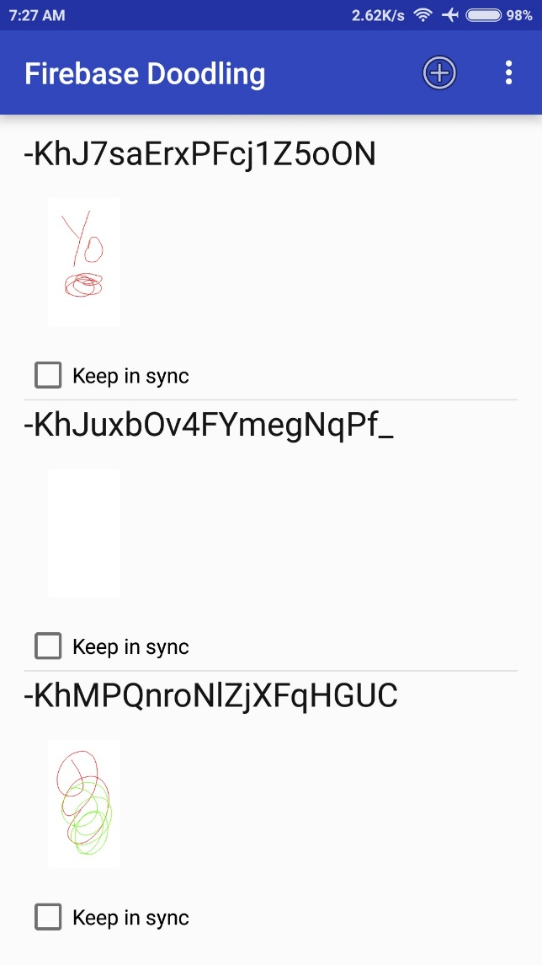Fig 2. Canvas List

Fig 2. Shows the list of all the canvases the user has created. As of now, the names of these canvases are pseudo-random strings that are calculated using the devices Android_ID. Future versions of the app will allow the user to set a custom name for each of these canvases.

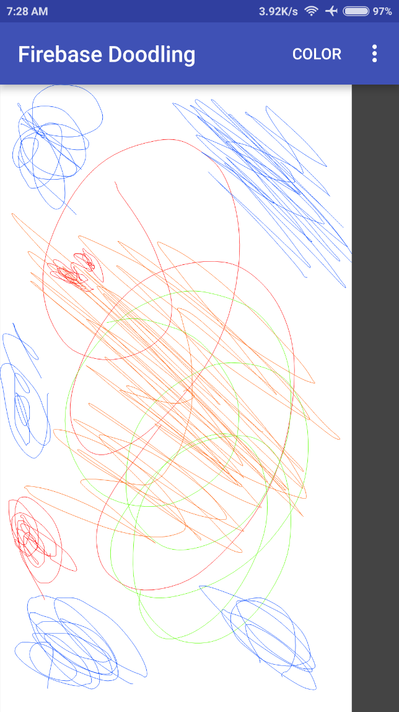Fig 3. Editing Canvas

Fig 3. Shows the screen that is used for editing the contents of the canvas. The user provides inputs in different colors that he can select from a wide palette of colors. The user gives inputs in form of gestures.

**Conclusion**

This Android app can be used in situations where you need to explain something to a person but in visual form. For example, you want to show an architect how you want your room to be constructed, or he wants to show you his final sketch of your house or this app is a good learning tool for toddlers and kids to understand the principles of drawing.

The app is in development stages now, but in future it can have complex functions to record inputs such as auto straightening of lines and curves input by the user.

**References**

http://fieldguide.gizmodo.com/12-android-gestures-you-might-not-know-about-1786423555

https://codelabs.developers.google.com/

https://developer.android.com/training/gestures/index.html

https://firebase.google.com/features/

https://firebase.google.com/